**Microprocessor Lab  
Lab Experiment No. 11**

Name: Ninad Rao Roll No. 53

**Aim**: Perform count of 1’s and 0’s in the binary bit system

**Instructions on how to use TASM**:

Steps for creating the program:

1. TASM is loaded
2. TASM < Edit - We will get an edit window
3. Type the program here
4. Save the file as <filename>.asm

Steps for running the program:

1. c:\tasm> Type here tasm filename

**c:\tasm> tasm <filename>.asm**

This will save the program, and the edit window with this file name will be seen.

1. c:\tasm> Linking the program

**c:\tasm> tlink <filename>.obj**

This will create an object file after linking.

1. c:\tasm> Now to execute the program and get to the result window

**c:\tasm> td <filename>.exe**

After execution, all the window options are present to check all registers, all memory locations and so on.

**Program to count 1’s and 0’s**:

**Explanation**: We have a word that is stored in the AX register. Initialize the counter 1 = 0 to count the number of 0’s. Initialize counter 2 = 0 to count the number of 1’s. We will rotate the number in AX alongwith carry by 1 bit to the right. If there is a carry we will increment counter 2. Decrement counter 1. This process will continue till all the bits are checked. The counter 2 will indicate the number of 0’s present in the number. The result of counter 1 is stored in AL. Same process to count 1's. Display the result.

**Algorithm**:

**Step I:** Load register A (accumulator) with the given data

**Step II:** Load register B with 08H to set up a decrement counter

**Step III:** Load register C as counter to count the numbers of 1’s (initial value 00H)

**Step IV:** Load register D as counter to count the number of 0’s (initial value 00H)

**Step V:** Rotate the content of Accumulator to left through carry

**Step VI:** If on carry from Step 5 then jump directly to Step 9

**Step VII:** Else increase counter C by 1

**Step VIII:** Jump unconditionally to Step 10

**Step IX:** Increase counter D by 1

**Step X:** Decrease counter B by 1

**Step XI:** Until B is not equal to 0 repeat from Step 5

**Code**:

.model small

.data

a db 27h

c0 db 0

c1 db 0

.code

mov ax, @data ; Initialization of data segment

mov ds, ax ; Loading of data segment

mov al, a ; Data in accumulator

mov cx, 0008h ; Counter or eight in cx

again: ROL al, 01h ; Rotate right one bit

jnc over ; If no carry jump to label over

inc c1 ; 1’s counter incremented by 1

jmp next ; Unconditional jump to next

over: inc c0 ; 0’s counter incremented by 1

next: loop again ; Repeat again

mov ah, 4ch ; Program termination

int 21h ; Software interrupt

end

**Output**:

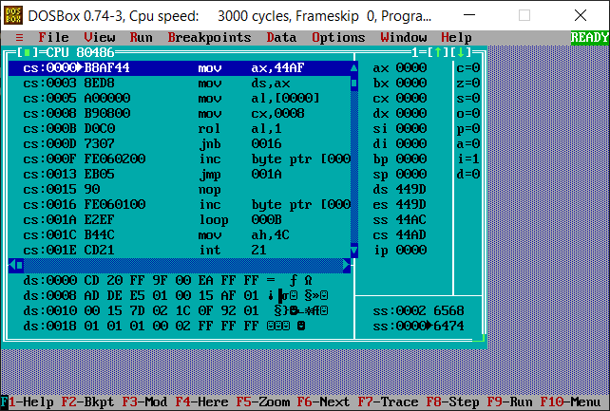

**Conclusion**: Thus, we have studied and understood the program to count 1’s and 0’s in the binary bit system.